1.
a)
interface MyInterface{
boolean perform(int a, int b);
}
public class FunctionalInterfaceLambdaEx {
public static void main(String[] args) {
MyInterface mi = (int a, int b)->{
if (a>b)
return true;
else
return false;
};
boolean res = mi.perform(7,9);
System.out.println(res);
}
}
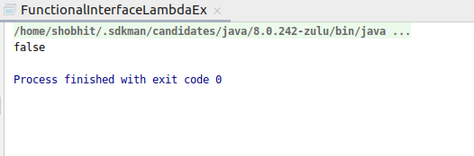

b)
interface MyInterface{
int perform(int a);
}
public class FunctionalInterfaceLambdaEx {
public static void main(String[] args) {
MyInterface mi = (int a)->{
a=++a;
return a;
};
int res = mi.perform(7);
System.out.println(res);
}
}
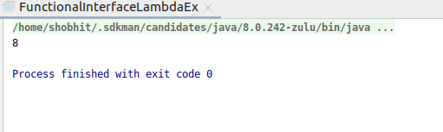

c)
interface MyInterface{
String perform(String s1, String s2);
}
public class FunctionalInterfaceLambdaEx {
public static void main(String[] args) {
MyInterface mi = (String s, String s1)->{
String s2 = s + s1;
return s2;
};
String res = mi.perform("Shobhit","Bisaria");
System.out.println(res);
}
}
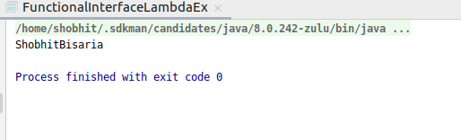

d)
interface MyInterface{
String perform(String s);
}
public class FunctionalInterfaceLambdaEx {
public static void main(String[] args) {
MyInterface mi = (String s)->{
String s1 = s.toUpperCase();
return s1;
};
String res = mi.perform("Shobhit");
System.out.println(res);
}
}
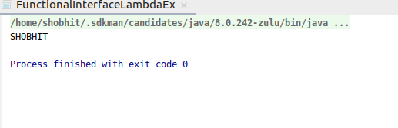

2.
interface Functional{
int print(int a, int b);
}
public class FunctionalEx {
public static void main(String[] args) {
Functional fun=(int x, int y)->{
return (x+y);
};
int val = fun.print(5,7);
System.out.println(val);
}
}
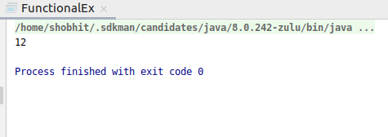

3.
a)add
interface Reference{
void display();
}
public class MethodRefernceEx {
void add(){
int a=7;
int b=3;
int c=a+b;
System.out.println(c);
}
public static void main(String[] args) {
Reference ref = new MethodRefernceEx()::add;
ref.display();
}
}
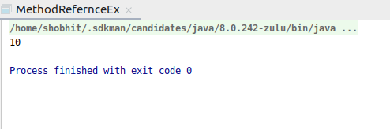

b)subtract
interface Reference{
void display();
}
public class MethodRefernceEx {
void add(){
int a=7;
int b=3;
int c=a-b;
System.out.println(c);
}
public static void main(String[] args) {
Reference ref = new MethodRefernceEx()::add;
ref.display();
}
}
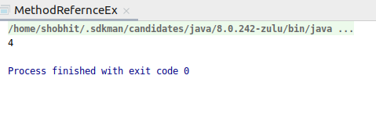

c)
interface MethodRefernce {
void disp();
}

public class StaticMethodReferenceEx {
static void multiply() {
int a = 5;
int b = 5;
int c = a * b;
System.out.println(c);
}

public static void main(String[] args) {
MethodRefernce ref = StaticMethodReferenceEx::multiply;
ref.disp();
}
}
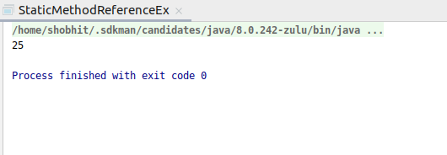

4.
//Employee class
public class Employee {
String name;
int age;
String city;

public Employee(String s, int i, String c) {
System.out.println(s+" "+i+" "+c);
}
}

//Driver code
interface EmployeeRef{
public abstract Employee getEmpDetails(String n, int a, String c);
}
public class EmployeeReference {
public static void main(String[] args) {
EmployeeRef er = Employee::new;
er.getEmpDetails("Shobhit",24,"Kanpur");
}
}
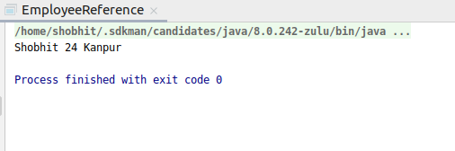

5.
a)Consumer
import java.util.function.Consumer;

public class ConsumerInterface {
public static void main(String[] args) {
Consumer consumer = (i)->{
System.out.println(i);
};
consumer.accept(5);
}
}
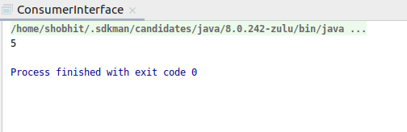

b)Supplier
import java.util.function.Supplier;

public class SupplierInterface {
public static void main(String[] args) {
Supplier supplier = ()->{
return 5;
};
System.out.println(supplier.get());
}
}
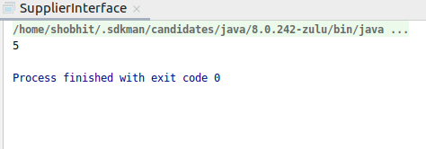

c)Predicate
import java.util.function.Predicate;

public class PredicateInterface {
public static void main(String[] args) {
Predicate<Integer> predicate = (e)->{
return e>2;
};
System.out.println(predicate.test(6));
}
}
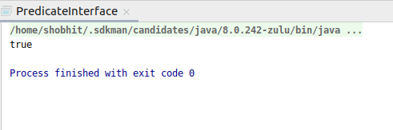

d)Function
import java.util.function.Function;

public class FunctionInterface {
public static void main(String[] args) {
Function<Integer,Integer> function = (e)->{
return e*2;
};
System.out.println(function.apply(5));
}
}
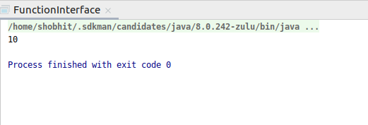

6.
interface DefaultInterface{
default void newMethod(){
System.out.println("default in interface");
}
void normal();
}
public class InterfaceDefaultEx implements DefaultInterface{
public static void main(String[] args) {
InterfaceDefaultEx obj = new InterfaceDefaultEx();
obj.normal();
obj.newMethod();
}

@Override
public void normal() {
System.out.println("abstract in interface");
}
}
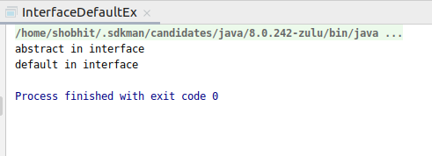

interface StaticMethodInterface{
default void first(){
System.out.println("default");
}
static void staticMethod(){
System.out.println("static method in interface");
}
}
public class StaticMethodEx implements StaticMethodInterface {
public static void main(String[] args) {
StaticMethodEx s = new StaticMethodEx();
s.first();
StaticMethodInterface.staticMethod();
}
}

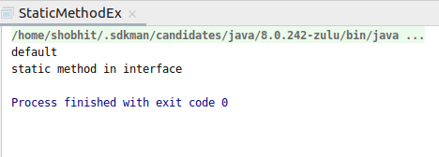

7.
interface One{
default void print(){
System.out.println("In one");
}
void norm();
}
interface Two{
default void print(){
System.out.println("In two");
}
void nor();
}
public class DefaultOverrideEx implements One, Two{
public static void main(String[] args) {
DefaultOverrideEx def = new DefaultOverrideEx();
def.print();
}

@Override
public void nor() {

}

@Override
public void norm() {

}
@Override
public void print(){
System.out.println("In class");
}
}
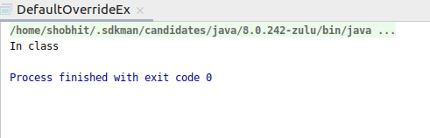

8.
interface One{
default void print(){
System.out.println("In one");
}
void norm();
}
interface Two{
default void print(){
System.out.println("In two");
}
void nor();
}
public class DefaultOverrideEx implements One, Two{
public static void main(String[] args) {
DefaultOverrideEx def = new DefaultOverrideEx();
def.print();
}

@Override
public void nor() {
}

@Override
public void norm() {
}
@Override
public void print(){
One.super.print();
Two.super.print();
}
}
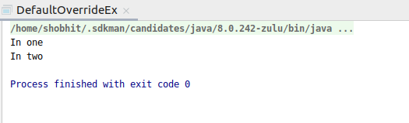

9.
import java.util.Arrays;
import java.util.List;
import java.util.stream.Collectors;

public class CollectEx {
public static void main(String[] args) {
List<Integer> list = Arrays.asList(1,2,3,4,5,5,6,7,8,9,0);
System.out.println(
list
.stream()
.filter(e->e%2==0)
.collect(Collectors.toList())
);
}
}
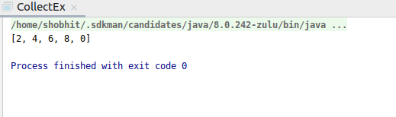

10.
import java.util.Arrays;
import java.util.List;
import java.util.stream.Collectors;

public class CollectSumEx {
public static void main(String[] args) {
List<Integer> list = Arrays.asList(1,2,3,4,5,6,7);
System.out.println(
list.stream().filter(e->e>5)
.collect(Collectors.summingInt(e->e))
);
}
}
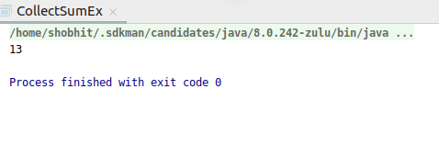

11.
import java.util.Arrays;
import java.util.List;
import java.util.stream.Collectors;

public class CollectAverageEx {
public static void main(String[] args) {
List<Integer> list = Arrays.asList(1,2,3,4,5);
System.out.println(
list.stream()
.collect(Collectors.averagingInt(e->e*2))
);
}
}
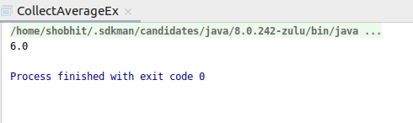

12.
import java.util.Arrays;
import java.util.List;
import java.util.stream.Collectors;

public class FirstEvenEx {
public static void main(String[] args) {
List<Integer> list = Arrays.asList(1,2,3,4,5,6,7,8,9,10);
System.out.println(
list
.stream()
.filter(e->e>3)
.filter(e->e%2==0)
.findFirst()
);
}
}
